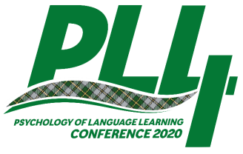 | Confirmation of Student Status  Psychology of Language Learning conference Cape Breton University, Canada, June 2020

The fourth international Psychology of Language Learning conference (PLL4) will be held at Cape Breton University, Sydney, Nova Scotia CANADA. Students pay reduced fees to attend. This form confirms that the person named below is a graduate or undergraduate student. Thank you for completing the form.
Peter MacIntyre
PLL4 Conference Organizer
Student Name
Degree or Program
Name of Supervisor or Department Chair
University
Address

I confirm that the student named above is registered as a student and eligible for reduced conference fees for PLL4.
Name of Supervisor or Department Chair
Signature

Insert here a copy of student ID card

